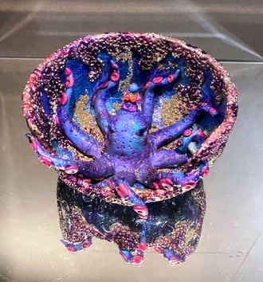
Polymer Clay Creations by
Judy Dunn

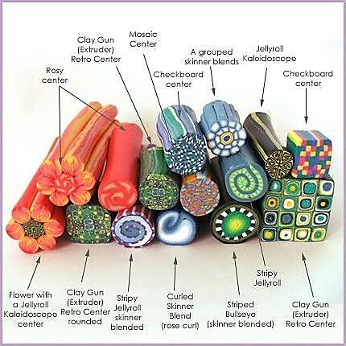
My love of polymer clay began in the late 80's when I was working and teaching classes at the Bead Garden at the Mission Mill and Michael's in Salem. I began making simple beads for my jewelry and from there I discovered cane work, which has become my passion.

A polymer clay cane is a log made of different colors of clay that are combined to create a design that runs through the entire log. The canes are then sliced and then combined in different ways to make patterns. I love the versatility of techniques you can use with polymer clay as well as the bright, vibrant colors you can create. The possibilities are limitless!

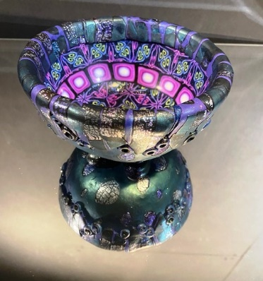
I also consign my art at Lunaria Gallery in Silverton, Oregon, where I was one of the original 25 founding owners.
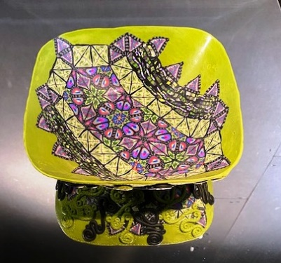
Judy
