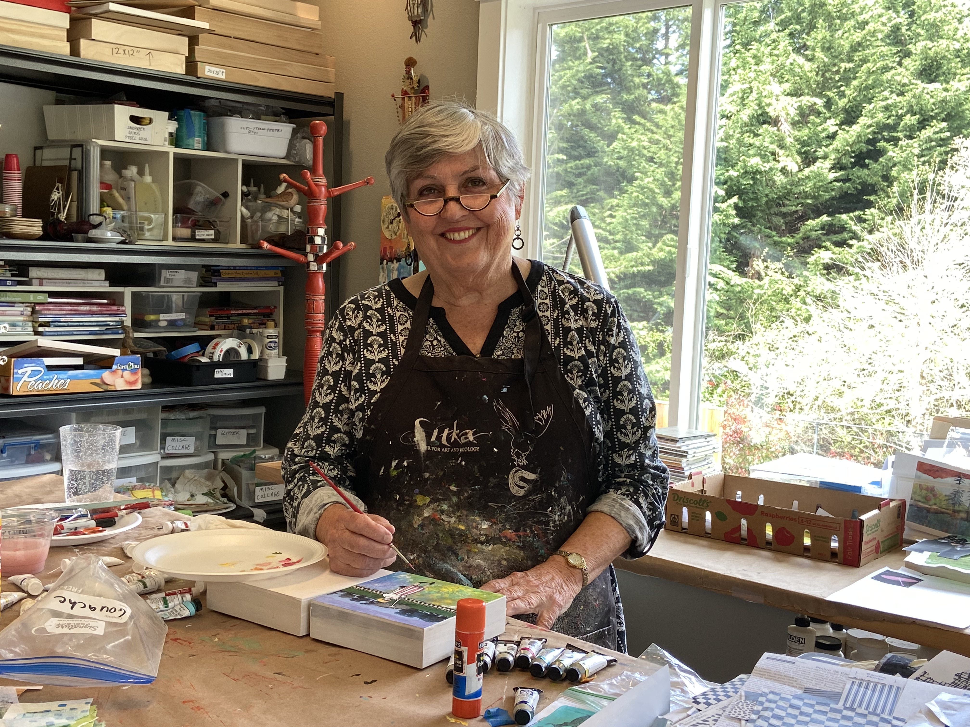

Deanna White – Biography
Deanna White began her education in art and design during her years at Cal Poly Humboldt, investigating such diverse expressions as sculpture, photography, theater costume design and puppetry, as well as the more traditional drawing and painting curriculum. She expanded her exploration of art by touring Europe, where she attended the Hohensalzburg Art Academy in Salzburg, Austria.
Deanna’s painting style draws on the drama and hyperbole of her theater arts training. Magenta hills, cerulean skies and bright gamboge tree trunks adorn her fantasy expression of the Mid Willamette Valley, which she sees in the woods and gardens on her daily walks and plein Aire excursions. Landscapes, people and still lifes painted in acrylic or soft pastel and collage currently make up most of Deanna White’s portfolio.
Deanna has been married to her husband Glen for 44 years and has two sons. She has explored many vocations during her life such as a woodshop instructor, dental assistant for 20 years, an antique dealer and an MA for a Vascular Surgeon. Concurrently for the last 23 years she has taught Watercolor, Encaustic and Pastel classes through Chemeketa College, Currents Gallery, SAA, KAA and her home studio.
Her work can be seen at Bush Barn Gallery, Currents Gallery, River Gallery, Elsinore Gallery and Corvalis Art Center.

