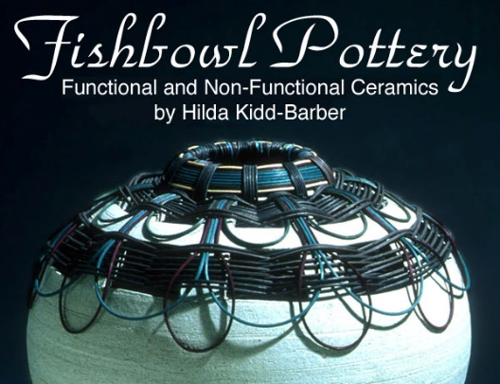
About Artist Hilda Kidd-Barber
Hilda Kidd-Barber (formerly Hilda Wiesenmeyer) has been creating her own special style of decorative pottery for about 20 years. She lived in Illinois all of her life and graduated from Millikin University with a BFA, majoring in ceramics. Clay is a part of who she is.

She has her own style, one of which is called “Basket Pottery” which incorporates pottery and various colors of dyed reed that are woven through the top to give a part basket appearance. In May of 2009, she loaded up her Honda Element with her pottery and drove to Oregon where she now resides. She brings a mid-western influence but quickly admits that Oregon has made a big impact on her work. Her studio is located in her home. You can see Hilda’s pottery at various art fairs and galleries in Oregon.

I believe that a ceramicist shares an equal relationship with the clay. One side should not dominate the other, but share in the formation of a finished piece. I rely on the clay to help in the decision making on the appearance of the final piece. The designs are not pre-conceived images, but are revealed to me through the spontaneous placement of the clay. I depend on the guidance of the clay to help in the choice of the decorative process. Patience and great care is taken to make sure that the extruded work adheres to the clay body so that they become a homogeneous blend. My intention is to create a visually and texturally interesting design to stimulate the senses of sight and touch.

I believe that art serves many purposes-- to be interesting and challenging, to create peace and harmony and to make a statement. I have tried to incorporate this philosophy into my artwork.
Hilda Kidd-Barber

