Dena Lynn Brehm

About Dena
The Introduction
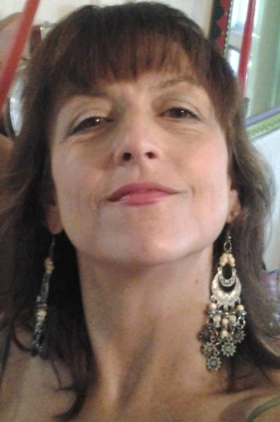
Hi there – I’m Dena Lynn, owner of Serendipities by Dena. I’m an irrepressibly creative-human, and a self-taught folk-artist.
My mission on planet Earth is to inspire every human I encounter to see and be who they truly are... and to find/discover/inspire beauty, everywhere I go. It’s what I can’t not do.
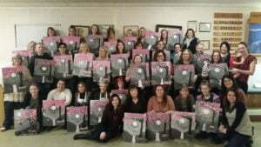
For decades now, I’ve been turning everyday-objects into art (Wonderland Art by Dena, hand-painted furnARTure & accessories), and everyday-humans into artists (Paint-Fun with Dena, a plethora of Paint-Parties).

The Beginning

I launched my own business on Leap Day of 2016, taking a leap of faith into the unknown. Since then, I’ve taught 1000s of people, from age 5-95, that yes, they can paint, and yes, it’s way more fun than they thought it would be!

And if you’re looking for unique, innovative, one-of-a-kind art for your home or business, or for unforgettable gifts… check out my Wonderland Art selections — I transform ordinary furniture, accessories and other objects into functional art! And YES, I am commissionable! I can transform what you already own, or even a wall of your home/business, into an heirloom-quality work of art.

The Wonderland Art
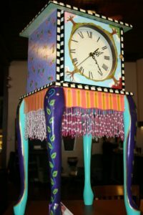 | 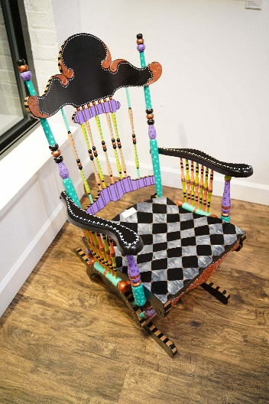 | 