Toby Wayne Larson
Artist Statement
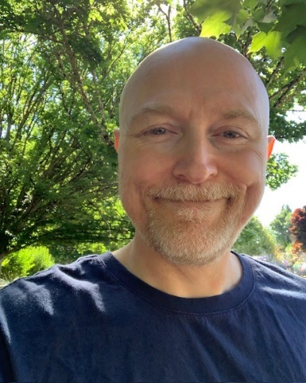
My name is Toby Wayne Larson and I have always been creating, whether drawing or painting. I had been bored with the typical projects in art class in high school and when I expressed my frustration, I was given my first chunk of oil-based clay.

That changed my life! Sculpting has been my passion ever since. I am so blessed to have found an art medium that makes me incredibly happy.

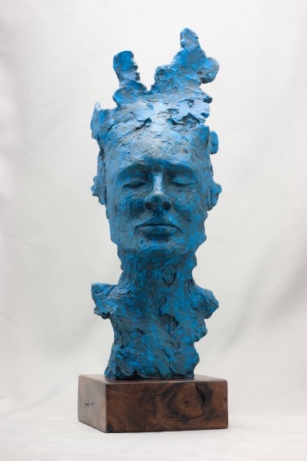
I have worked with resins, waxes, bronze and currently I am really enjoying ceramic work. I love the unpredictability of the ceramic processes as once the sculptures are stained and glazed and placed in the kiln, they are going to do what they are going to do.

Sometimes it’s exactly as I envisioned and other times, not so much. It really teaches me every time I do a firing, to go with the flow and to embrace the idea that the artist isn’t always in control.

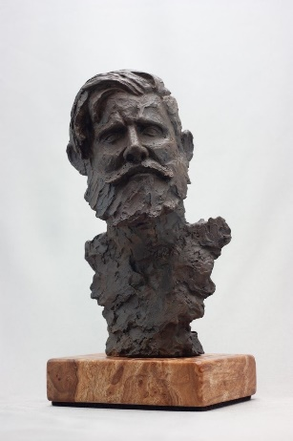
I hope you enjoy my sculptures as much as I enjoy making them!

You can see more of my work and watch the creative processes of how I create my sculptures on my Instagram @tobywayneart

You can also visit my website www.tobywayneart.com

