The Art of J.M. Brodrick
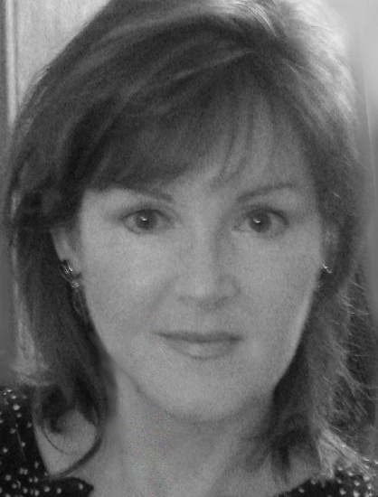
Biography Brodrick's paintings are in numerous corporate collections in the United States and Europe including: Atlantic Richfield Corporation, the embassy of the Russian Federation in Washington D.C., and the State of Alaska with a twenty-six foot painting at the Fairbanks International Airport.
Brodrick studied painting and classical music in her youth and received her first scholarship at the age of 13. Her Grandmother, who was a professional artist in Helsinki Finland, guided her love of the arts. She grew up in a working artist environment. "My Grandmother helped me connect with other artists and shaped me at an early age to express myself with painting" says Brodrick. In 1977, she moved to Fairbanks Alaska where the rugged lifestyle and freedom of the open country inspired her to further develop her artistic talents. Brodrick now lives in Oregon and is surrounded by the beauty of the Pacific Northwest.
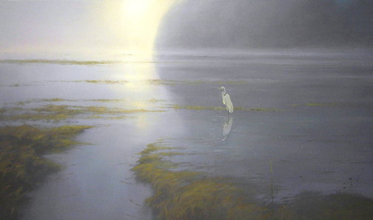
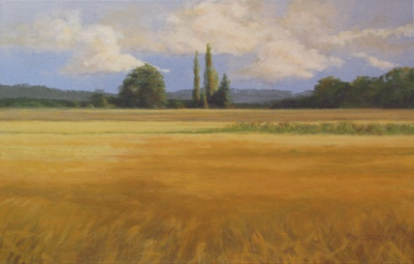
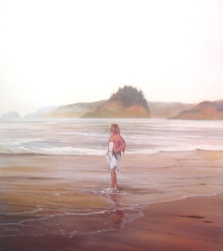
COLLECTIONS
Sacred Heart Medical Center at Riverbend - Eugene, Oregon
The Embassy of the Russian Federation - Washington D. C. -Two Paintings in their Permanent Collection
State of Alaska - Fairbanks International Airport -Twenty-Six Foot Painting for the Airport
Alaska Siberian Institute - Juneau, Alaska -- Nine Paintings in their Permanent Collection
Atlantic Richfield Corporation - San Francisco, California--Two Paintings in their Permanent Collection
Dr. Michael and Edy Dorsen - Portland, Oregon
Willam and Marjory Varitz - West Linn, Oregon
Tony Knowles, Former Governor of Alaska - Anchorage, Alaska
Dr. Warren V. Bush - Dallas, Texas
Grace Schible, Former Attorney General - Anchorage, Alaska

EXHIBITS
2011 Solo Exhibit -Elsinore Fine Art Gallery - April 2011 -Salem, Oregon
2010 Fine Art View's "Bold Brush" November Painting Competition -Best Acrylic Award
Caswell Gallery - New Works - Featured Artist November/December -Troutdale, Oregon
Fine Art View's "Bold Brush" October Painting Competition - Finalist Award
Raymar Art Fine Art Competition - Fifth Annual Competition October Finalist
Lawrence Gallery - New Works Exhibit - September/October -Sheridan, Oregon
Fine Art View's "Bold Brush" SeptemberPainting Compeition - Top 15% FAV Award
My Oregon - Group Exhibit September- River Bend Fine Art -Bend, Oregon
Fine Art View's "Bold Brush" August Painting Competition - Finalist for Best Acrylic
Fine Art View's "Bold Brush" August Painting Competition - Top 15% FAV Award
Fine Art View's "Bold Brush" July Painting Competition - Finalist for Best Acrylic
Fine Art View's "Bold Brush" July Painting Competition - Top 15% FAV Award
Lawrence Gallery - New Works Exhibit - May/June -Salishan, Oregon
Fine Art View's "Bold Brush" June Painting Compeition - Top 15% FAV Award
Ruth and Jim Howland Community Open Exhibit -People's Choice Award -Corvallis, Oregon Watercolor Society of Oregon’s 45th Annual Aqueous Show -juror, Stephen Quiller
River Bend Fine Art Grand Opening - May - River Bend Fine Art Gallery -Bend, Oregon
2009 Plein Air Painters of Oregon Juried Exhibition - High Desert Gallery- Bend, Oregon
Lawrence Gallery - Sheridan, Oregon - July/August
Sacred Heart Riverbend - Eugene, Oregon - August/October
2008 Group Exhibition - Lawrence Gallery, Sheridan, Oregon
2007-1998 Medical leave
1997 Originals in Miniature International Exhibit, Stevenson Gallery- Corvallis, Oregon
1993 Linn-Benton Open Exhibition, Corvallis Arts Center -Corvallis, Oregon
1987 National Art Exhibition of Alaska Wildlife, Juried Exhibit- Artique Gallery - Anchorage,AK.
Wildlife & Environmental Art Show, Juried Exhibit- Wilshire Ebell Art Salon-
Los Angeles, CA.
Solo Exhibit - Signature's Gallery- Fairbanks, Alaska
1986 National Art Exhibit of Alaska Wildlife, Juried Exhibit- Artique Gallery- Anchorage, AK
All Alaska Juried Art Exhibit- Alaska State Museum- Anchorage, Alaska
Contemporary Realism Juried Exhibit-Leslie Levy Gallery- Scottsdale, Arizona
1986-1989 Group/Solo Exhibits- Gallery of the North- Juneau, Alaska
1985-1988 Solo and Group Exhibitions, House of Wood Gallery- Fairbanks, Alaska
1982 All Alaska Juried Art Exhibit- Alaska State Museum -Anchorage, Alaska
1978-1988 Solo Exhibitions and Group Exhibitions, New Horizons Gallery - Fairbanks Alaska
AWARDS AND PUBLICATIONS
2010 November - Fine Art View's Bold Brush Painting Competiton -Finalist for Best Acrylic Award
2010 October -Fine Art View's Bold Brush Painting Competition- Finalist Award
2010 October Finalist Raymar Art Fifth Annual Competition - Finalist Award
2010 September -Fine Art View's Bold Brush Painting Competition - Top 15% FAV Award
2010 August Fine Art View's Bold Brush Painting Competition - Finalist for Best Acrylic
2010 July-Fine Art View's Bold Brush Painting Competition - Finalist for Best Acrylic
2010 July-Fine Art View's Bold Brush Painting Competition - Top 15% FAV Award
2010 June -Fine Art View's Bold Brush Painting Competition- Top 15% FAV Award
2010 Ruth and Jim Howland Community Open Exhibit Corvallis, Oregon "People's Choice Award"
2008 American Art Resources - National Competition - Purchase Award- Houston, Texas
1993 Linn-Benton Open Exhibition, Corvallis, Oregon "People's Choice Award"
1986 Alaska Fish & Game Magazine - Cover Page Art - July/August Issue
1988 Alaska Waterfowl Conservation Stamp - Awarded Third Place in the National Competition
1982 Fairbanks International Airport - National Competition - Purchase Award
1982 The Alaska Journal -Cover art for the July/August issue
1982 All Alaska Juried Exhibit- Alaska State Museum- Anchorage, Alaska "People's Choice Award"
MEMBERSHIP: Watercolor Society of Oregon
EDUCATION- Independent studies with:
Sandra Tischnor, University of Michigan,- Ann Arbor, Michigan
Franklin Jones- Stockbridge, Massachusetts
Nita Engle- Traverse City, Michigan
Anita Peterson- Helsinki, Finland

