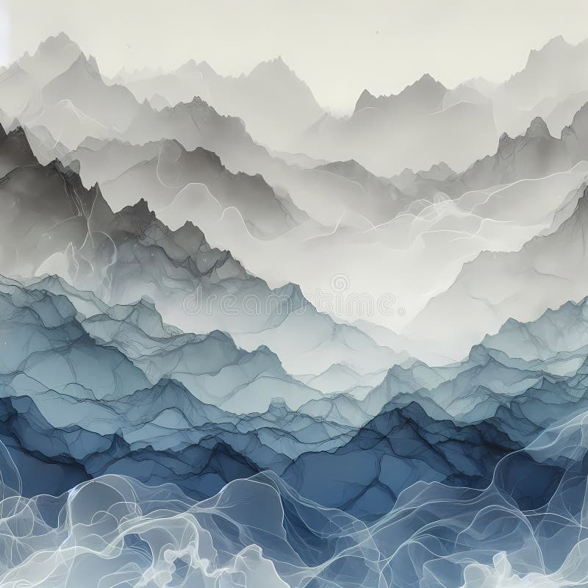


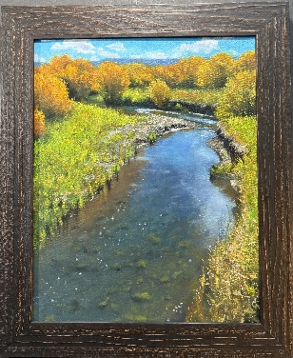
Craig Zuger
My interest in becoming a professional artist began in 1981 when I was invited to participate in the re-enactment of 175th anniversary of Lewis & Clarks homeward-bound journey. The trip would take six months to complete from March 23rd to September 23rd.

I had been interested in art and actively painting up until that departure date, but as the weeks and months passed on the journey my calling became clear. I wanted to paint the land...the things ‘west’.

Years later I had the good fortune to meet and be mentored by wildlife painter Terry Isaac, who graciously guided me into the world of being a professional painter. His lessons were invaluable to me. I had worked with a friend of mine on his wildlife field guides which took his research into the back country, and I would assist him and gain subjects to paint as a result. Oregon Public Broadcast (OPB) did a three-part story about him, and I was along to assist again. I asked the field producer if a show about Oregon wildlife artists would be of interest, and they agreed it would. I helped gather a list of artists to consider, and along with Terry Isaac, they asked me to be included as well.

I have worked tirelessly to improve and learn every day, never resting. The excitement of the education of painting motivates me to excel. I have been represented by several galleries throughout the years including Mockingbird Gallery in Bend, OR. Rimrock Gallery in Prineville, OR., Legends of the West Fine Art in Santa Fe, NM. and Oh Be Joyful Gallery in CO.

I was included in an issue of Art of The West magazine a few years back in an article titled ‘For the Love of Oils’. I have participated in many art shows throughout the years all over the west, from Scottsdale to Seattle. I don't have the accolades that some artists have. I have not been diligent in marketing myself, which has hampered much of my success, I fear. Or perhaps I need to paint better?

I don't sell online but prefer a strong gallery/artist relationship. It's crucial to have work represented by professionals who know the business and promote while I can focus on painting. I actively seek representation with care. I want to be where the mutual appreciation is a true partnership. I belong to Oil Painters of America and The International Guild of Realism. I don't have a long list of awards. I have spent much time trying to honor the landscape through my work, painting with artistry for the viewer.

